**Protocol for generating P-BEST sample pools:**

**General notes:**

* The current protocol is designed for pooling 384 samples in lysis buffer into 48 pools which are then tested via the standard PCR-based SARS-CoV-2 diagnostic test, including RNA extraction
* Before the first use, the Arise Biotech's EzMate™ 601robot should be calibrated for the 384 plates and the 2-ml tubes. Special holders are required.
* Pooling program takes about 5.5 hours for 384 samples
* Tips need to be replaced after every 96 samples are pooled.

**Step 1: Sample preparation for pooling protocol**

Goal: To pool samples, they need to be transferred into 96 well plates which the robot will then use for assembling the pools

IMPORTANT: The current protocol assumes samples were pre-incubated with lysis buffer and are therefore non-infectious. All pooling work is performed on a bench in standard BSL-2 laboratory settings

Sample handling: We have observed a drop in PCR sensitivity (~ 5 cycles) as samples undergo a freeze-thaw cycle after dilution in lysis buffer. Therefore, it is recommended to leave samples refrigerated prior to pooling.

384 swab samples diluted in lysis buffer are assumed to be placed in 5ml test tubes. **A minimal volume of 100 microliters is required for every tube**

1.1 Using 200ul filter tips [cat#1016, supplier Bar-Naor], transfer 100ul of each 384 different swab samples, after lysis, to single well in four 96 PCR plates [Labcon cat#LC3977-520, supplier Alex-red].

· Make sure to use a new tip for each sample to avoid contamination.

· Plate 1 contains samples 1-96 in horizontal order, plate 2 contains samples 97-192, plate 3 contains samples 193-288 and plate 4 contains samples 289-384.

· The samples are arranged as follows: (**notice ordering is by row** - horizontal)

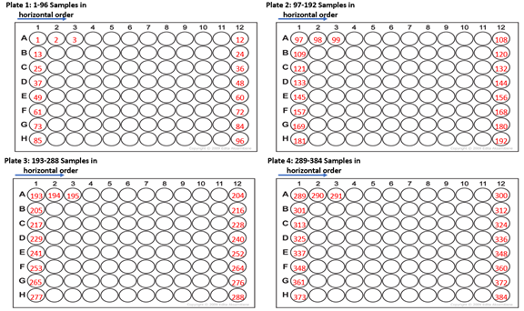

· Cover the prepared plates with a plate sticker [tape pads 5 QIAGEN, cat#20-19570, supplier ilex BioTech].

**Step 2: Assemble samples into 48 pools**

2.1. Prepare 48 2ml screw-cup micro tubes [cat#72.694, supplier Tamar Laboratory Supplies], marked with stickers [cat# 9138-2753, supplier Yarden Biotech] from pool 1 up to pool 48.

· Put the tubes in the stand designed for the EzMate 601 robot in the following order:

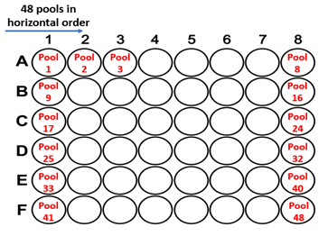

· Make sure that all 48 tubes are open.

3. Preparing the 48 pools with the Arise Biotech's EzMate™ 601

· Connect to the robot automated pipetting system APM channel 1, Capacity volume 10-200µl connected.

· Centrifuge the 1 and 2 96 PCR plate, for 5 minutes at 2000 rpm, at room temperature.

· Gently remove the sticker that covers the plates, avoiding splashing of the samples when removing the sticker.

· Arrange the plates, tubes and tips in the robot according to the following instructions:

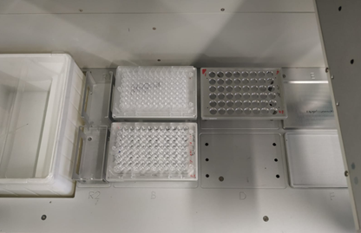

Plate 1 and plate 2 (96 PCR plates that were prepared in step 1) situated at positions A and B respectively. Position C contains 48 micro tube 2ml ( prepared in step 2.1) horizontal order in a 48 well holder. Position F contains 96 robotic 200 ul filter tips [Beckman-style from Axygen, cat#FXF200RS81876, supplier Bio-Lab].

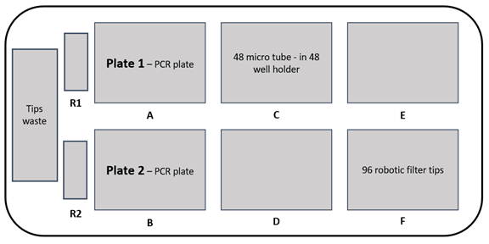

· Open the sample transfer program protocol, as listed in appendix 1 (Link).

The name of two first plates is:

**EZMate_384_to_48_pools_MD_commands_plates_1_2.csv**

· Note that a tip box should be replaced in the middle of the protocol (the robot stops working and allows the tips to be replaced).

**** **Before running the script, the software will ask to save the protocol, and in the next program run, the saved protocol can be uploaded directly without the need for a script.** appendix 2 (Link).

· When the robot finishes the protocol, the 96 PCR plates and the tips must be replaced:

· Centrifuge the 3 and 4 96 PCR plate, for 5 minutes at 2000 rpm, at room temperature.

· Gently remove the sticker that covers the plates, avoiding splashing of the samples when removing the sticker.

· Plate 3 and plate 4 (96 PCR plates that are prepared in step 1) situated at positions A and B respectively. **The 48 pool tubes remain in place.**

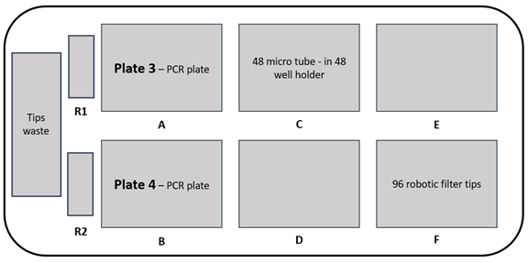

· Open the sample transfer program protocol, as listed in appendix 1 (Link).

The name of second script is:

**EZMate_384_to_48_pools_MD_commands_plates_3_4.csv**

· Note that a tip box should be replaced in the middle of the protocol (the robot stops working and allows the tips to be replaced).

4. When 384 samples are transferred to 48 pools, the 48 micro tubes must be closed and stored until the RNA extraction and qRT-PCR.

· The tubes must be stored at +4oC or -80 oC, depending on the time when you will start with the RNA extraction.

· The volume of each micro tube out of the 48 pools is 528ul.

5. Before the RNA extraction, using 1000ul filter tips [Axyegn cat#8187630201101, supplier Biol-Lab], transfer 510ul from each of the 48 micro tubes into 5ml tubes [cat#55-21054, supplier De-Groot], marked with matching stickers (pool 1 up to pool 48).

· Make sure to exchange tips in each pool.

**Step 3: load Ezmate script for pool assemble:**

3.1 Open EzStarter software

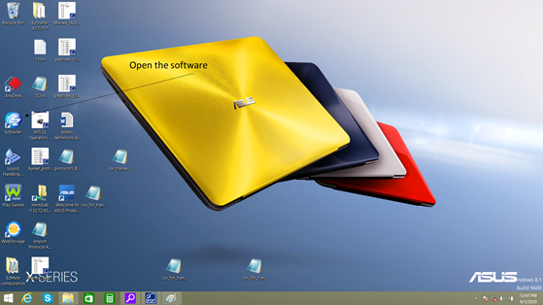

3.2 In position A, Press on the logo (1) to open the plates list and choose the PCR plate (2).

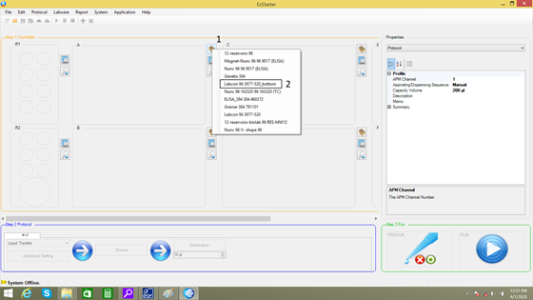

3.3 Repeat step 2 for position B.

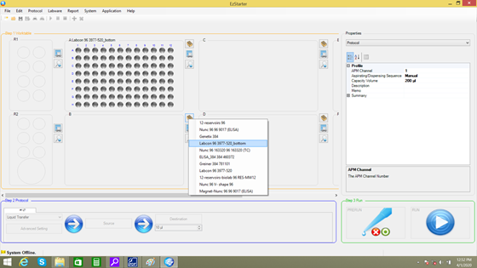

3.4 In position C press the logo (1) to open holders list and choose the 48 tube holder (2).

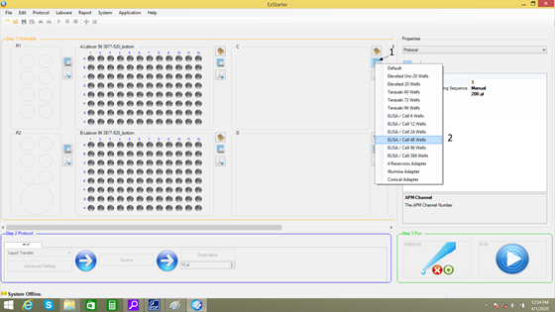

3.5 Click on the holder to choose the tube.

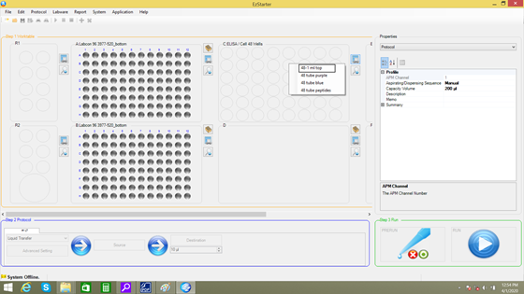

3.6 In position F press the logo (1) to open tip list and choose 165µl Filtered Sterile (2).

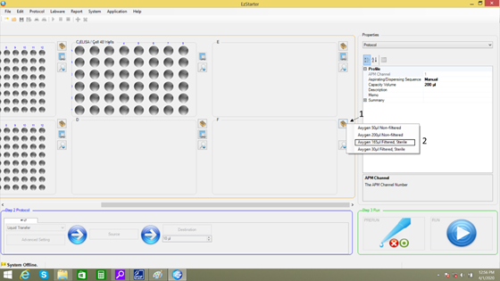

3.7 After loading the tips sign the places containing tips.

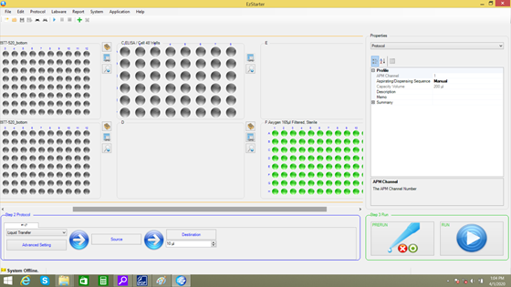

3.8 For loading the script press File (1) and then Open (2).

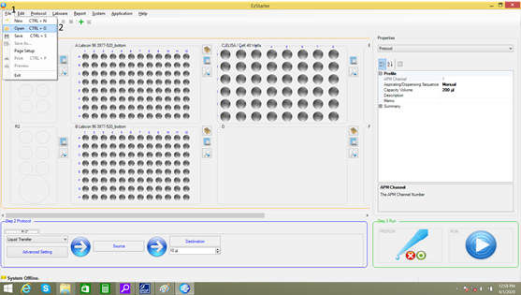

3.9 The software will ask you if you want to save Protocol Setting Changes, click no.

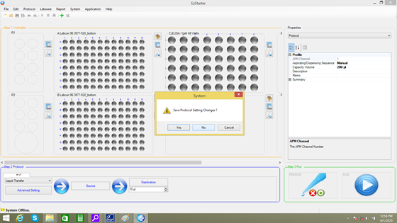

3.10 Open Aps Files window will open, choose Script option.

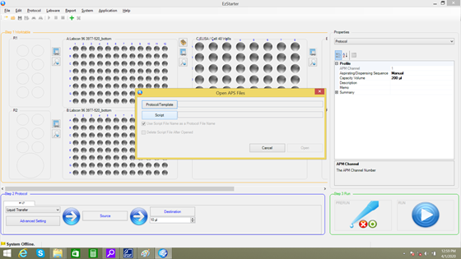

3.11 To open the script, choose the folder containing the script with csv end and choose the script.

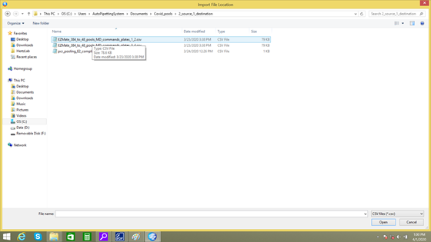

3.12 Click open to open the script.

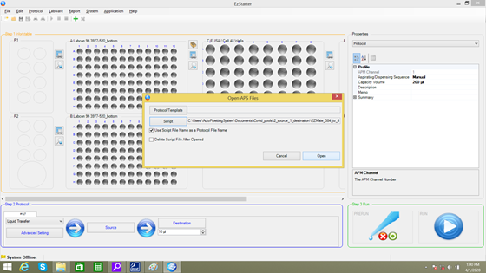

3.13 To save the script as protocol click File (1) and then Save (2).

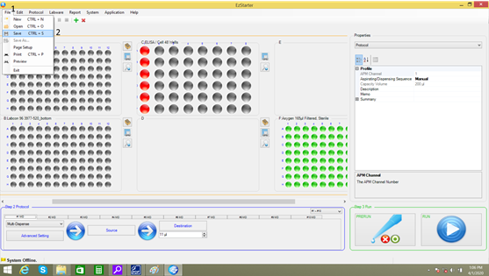

3.13 Choose the folder you want to save the protocol and save the file with aps end by clicking save.

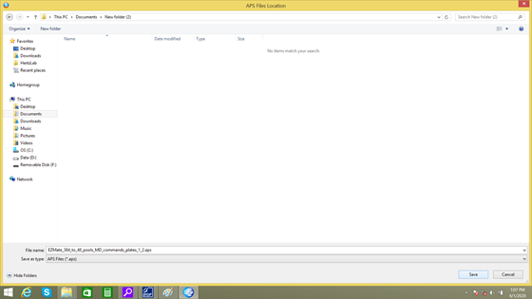

**Note: after these steps there is no need to load the specific program as a script. There is an option to load as protocol.**

**Step 4 : Load EZmate protocol**

4.1 Open EzStarter software

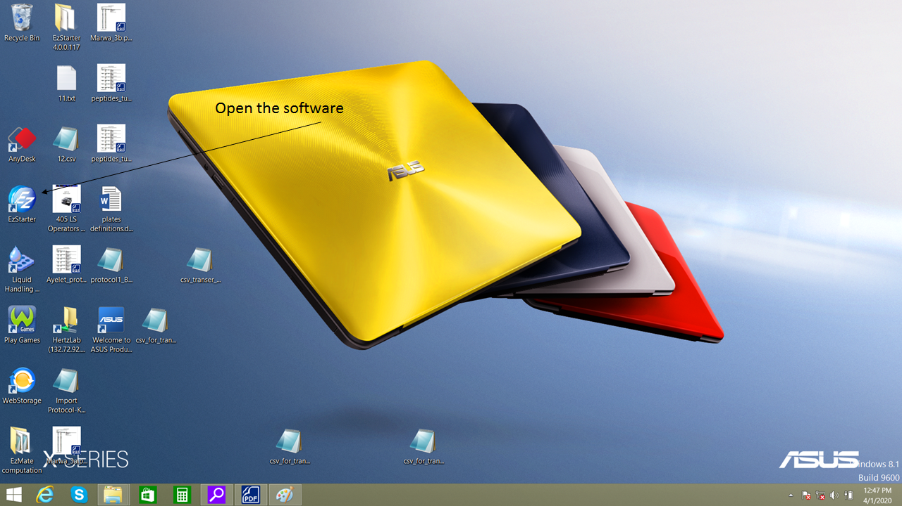

4.2 Click File (1) and then Open (2).

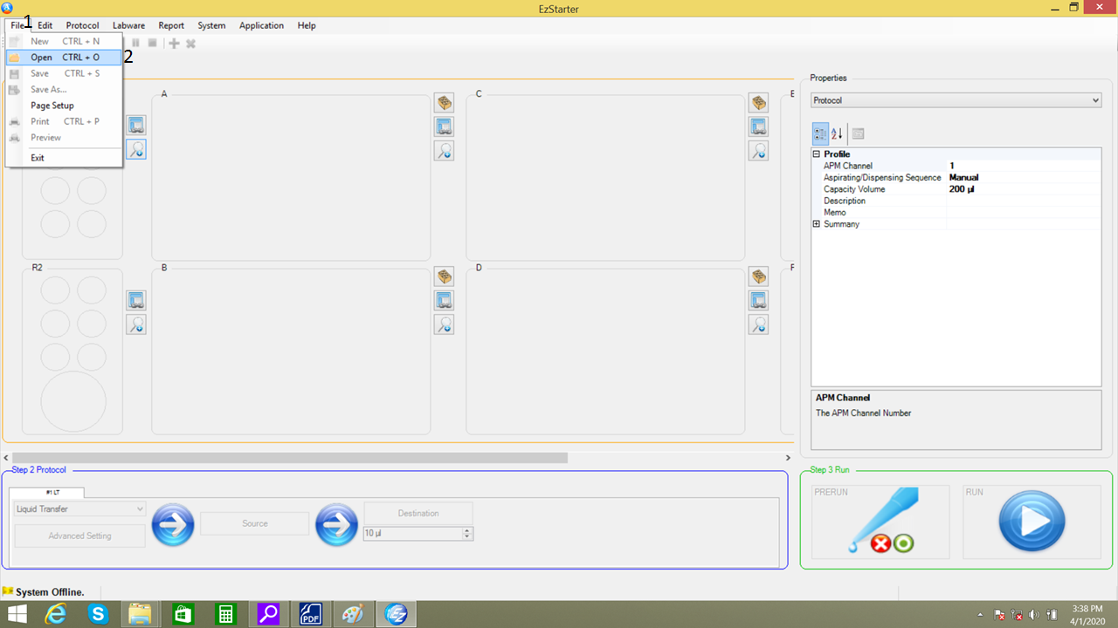

4.3 Click on Protocol/Template.

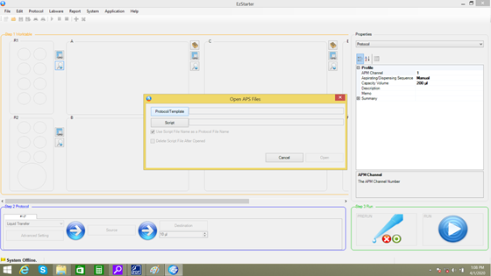

4.4 Choose the folder containing the protocol and choose the file with aps end.

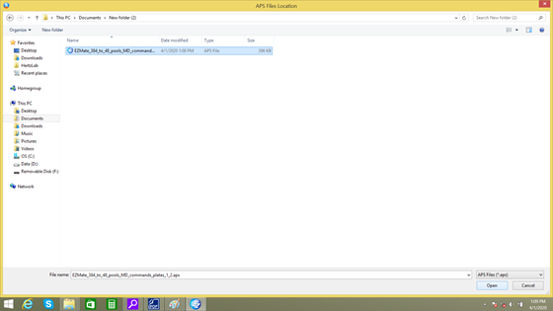

4.5 Click open to open the protocol.



4.6 After the protocol loaded click on RUN.

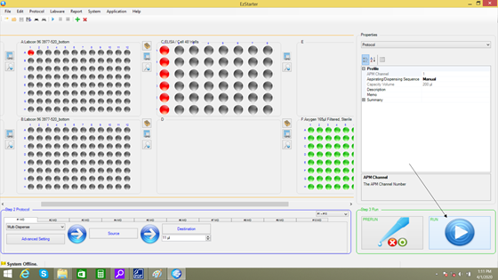

4.6 Make sure the plates, tubes and tips are in the right place and uncovered. Check the list and click on Go.

